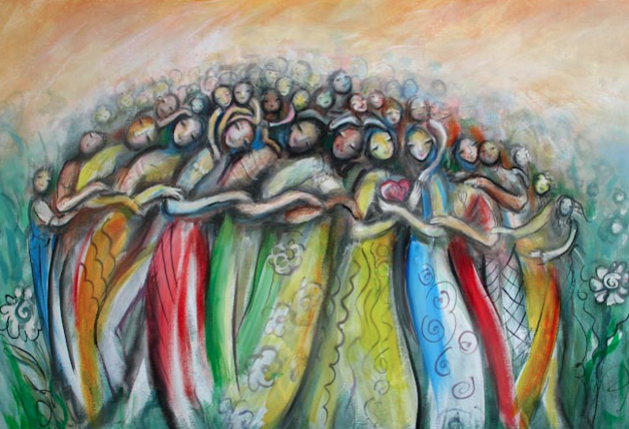  Grace Groups of Winnipeg  Mental wellness support groups for women who are walking alongside someone with mental health challenges or walking their own mental health journey.  Every other Wednesday @ 7:30 p.m. at Eastview Community Church or every other Friday @9:30 a.m. at Douglas Mennonite Church  Contact Helen at:  https://helenguenther64.wixsite.com/website-2  or call 204-771-1702 for more info or to reserve a spot. | - Explore common mental wellness topics  - Provide understanding, encouragement and support  - Discover insight and tools for each of our, or our loved ones, journeys  - Discover God’s grace, healing and steadfast love for better days to come

