Message from MCC

No images? Click here

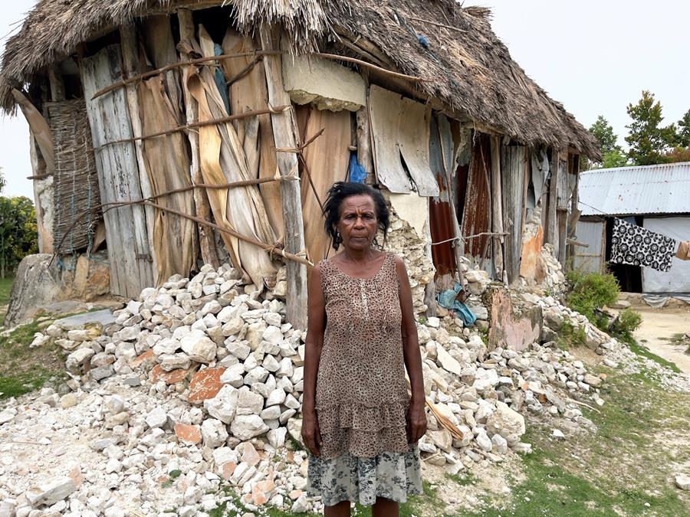

Giving thanks in Haiti
On August 14, a 7.2 magnitude earthquake struck Haiti, leaving 2,000 people dead and over 600,000 people in need of emergency relief. With help from our partners, MCC was the first to deliver supplies to the southwestern region of Saint-Jean-du-Sud. "Thank you for not leaving us alone," said one woman as she received canned meat and a relief kit. Learn more about how your support is helping to meet the immediate needs of earthquake survivors.
Send relief to Haiti earthquake survivors

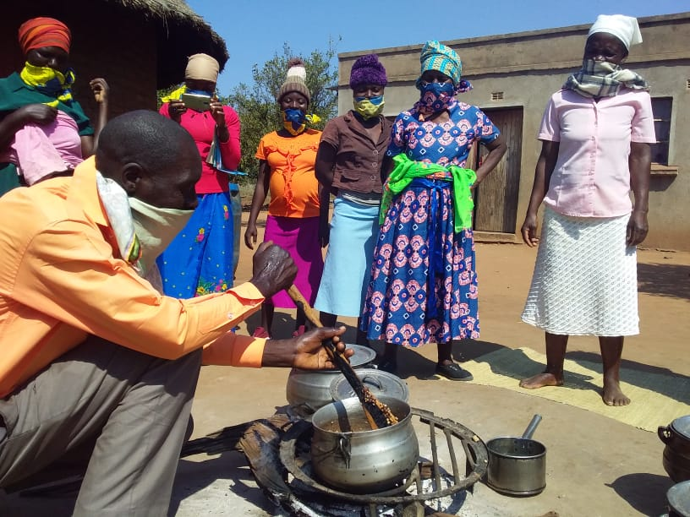

"Stirring the pot" in Zimbabwe
What does a cooking competition have to do with gender equality and food security? In the Mwenezi district of Zimbabwe, a cooking competition for men is turning heads and challenging stereotypes. Read more about how the Men Can Cook competition is promoting peace and gender equality.

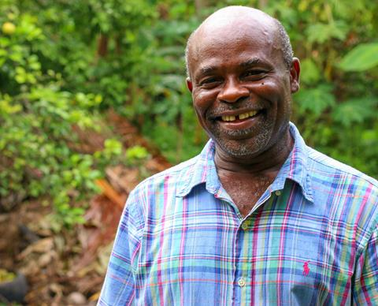

Job openings
- Peacebuilding Coordinator - Burundi
- Program Specialist for Burundi Education and Peace Partners

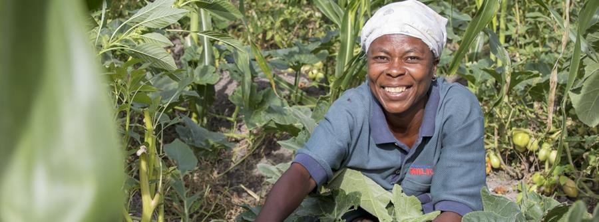

What's going on

Buckets of Thanks
- This year is one we couldn't have imagined. But many of us still have much to be thankful for. Will you join us in showing gratitude by giving a Bucket of Thanks this fall? It's a container filled with essential hygiene items, also known as a relief kit. Even in a pandemic, we send these kits all around the world to families in need. Learn more and start filling a Bucket of Thanks today.

MCC and climate change: Responding to climate change risks, October 22 at 11 am CDT
- Join us for this webinar as we explore the ways that MCC works to address food security and climate change through different farming techniques, policy approaches and advocacy. Learn more and register today.

Relief, Development and Podcast: Responding to the earthquake in Haiti​
- In this episode we look at the recent earthquake in Haiti, hearing about the vast and diverse needs in the affected communities. We talk to global health coordinator Paul Shetler Fast about the first distribution of relief and what a long-term response might look like. We also talk to MCC staff Muriel Chaporon about the importance of getting relief to women as well as responding to the trauma that people have experienced. Listen to the episode.

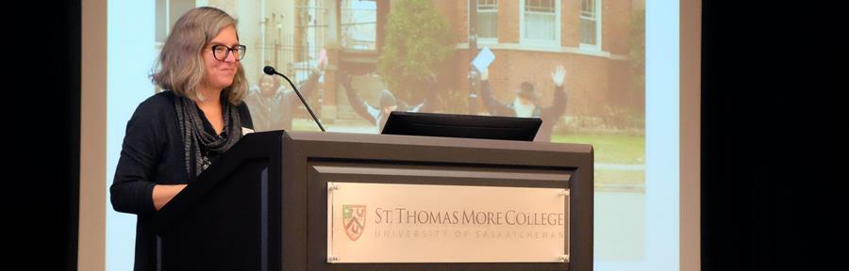

Peacebuilding speakers bureau
Peace is the foundation of everything we do at MCC. We know that relief and development work are only sustainable long-term when there is stability and peace.
We have a variety of speakers who work closely with MCC’s programs at home and around the world who can share inspiring stories of peace with your class or congregation.
Each speaker will help your group understand what peacebuilding looks like in everyday life and how it is integral to MCC's work.
Learn more and book a speaker today!

Share
Tweet
Forward
MCC Manitoba
134 Plaza Drive, Winnipeg, MB R3T 5K9
Clicking unsubscribe will remove you from the In Touch newsletter mailing list. Send us a note at intouch@mcccanada.ca or reply to this email if you'd like to be removed from all MCC emails.
Unsubscribe

